Transaction Report Tool Tutorial:

-This tool is meant to show you different Transactions, its' contents, and a list of the related documents linked to each one. It allows to perform a smart search by fields, that returns the
candidates and classifies them by the number of similarities with the different search terms.

Initial screen:

-Here we can see the different panels in the tool:

Blue: SEARCH TAGS CREATION PANEL.

-It will allow us to create “Search Tags”, filters to take into the account in the smart search.

Orange: TRANSACTION EXPLORATION PANEL.

-It will allow us to explore the contents on the Transactions.

Green: GENERATE REPORT BUTTON.

-It will generate a report in a PDF, with the contents of the selected Transactions.

Red: TEMPLATE OPTIONS PANEL.

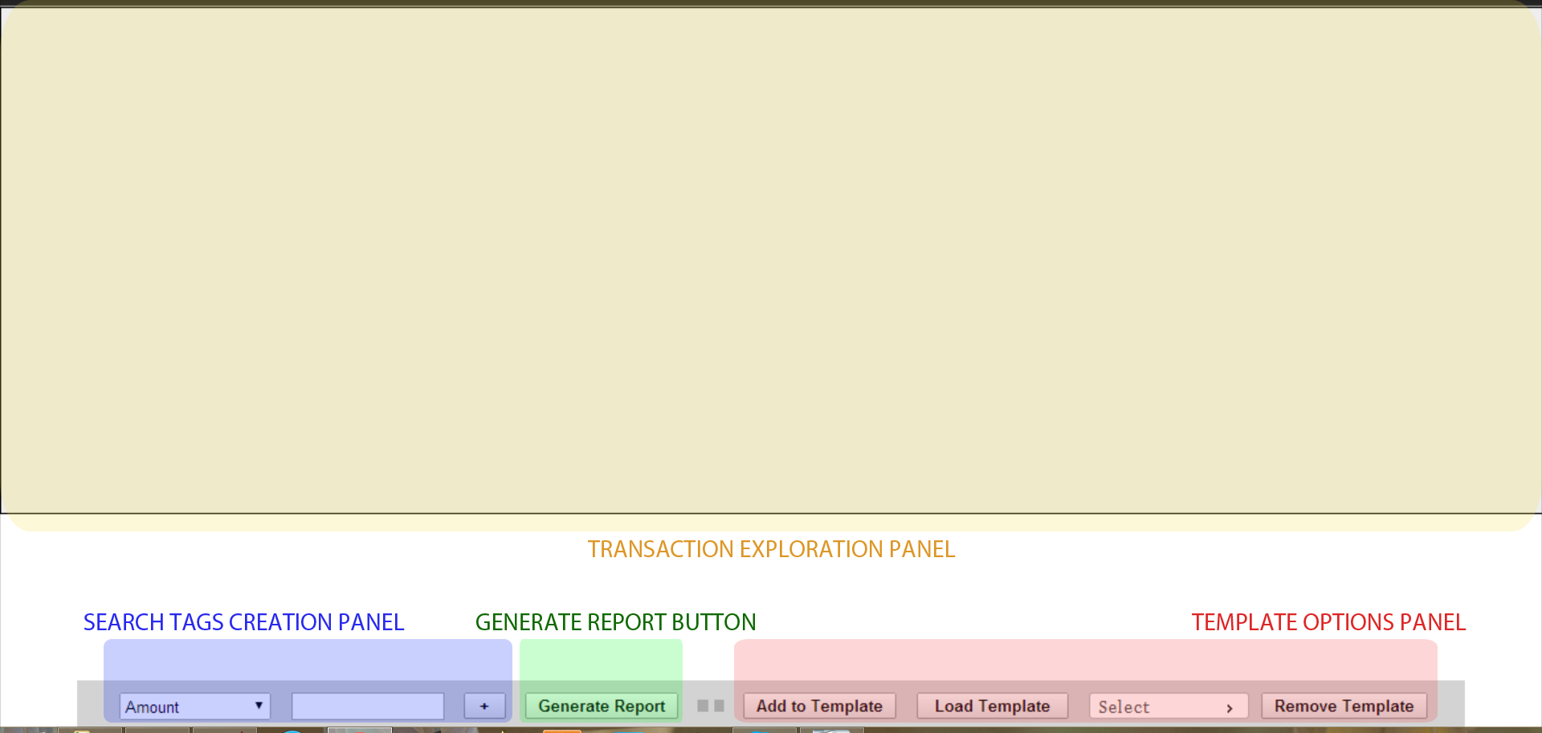
-It will allow us to Add selected Transactions to a pre-existing template, as well as create, load and remove templates.

Creating Search Tags:

Here is a breakdown of the creation of Search Tags.

1.Select the type of tag you want to create. This determines in which fields of the Transaction the search will be made.

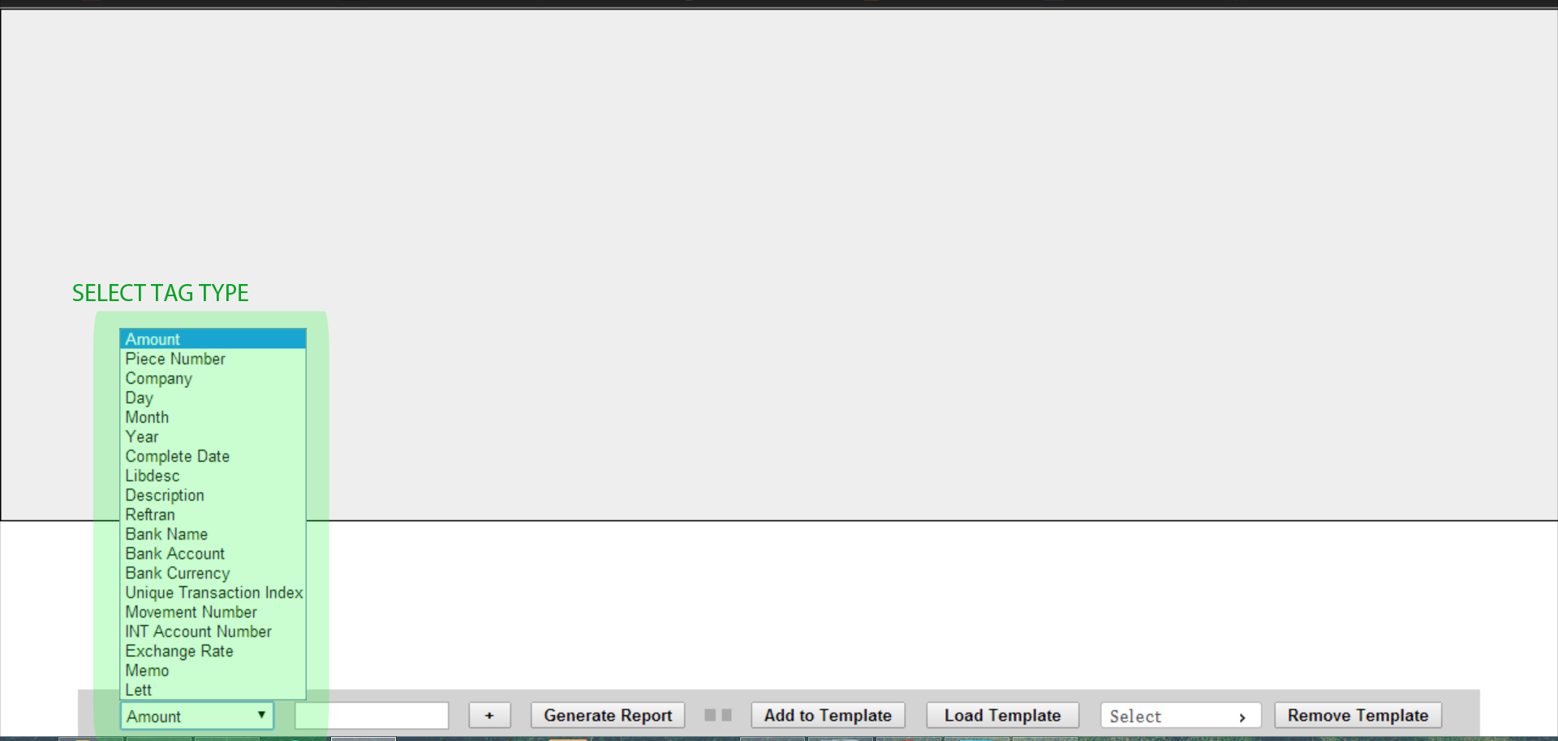
The tag type “Unique Transaction Index” is a special one, as it will always deliver at most one Transaction; the one with the same Transaction Index. This is perfect to explore a single Transaction with a previously known index.

2.Write the text to search for in that field and pull out candidates.

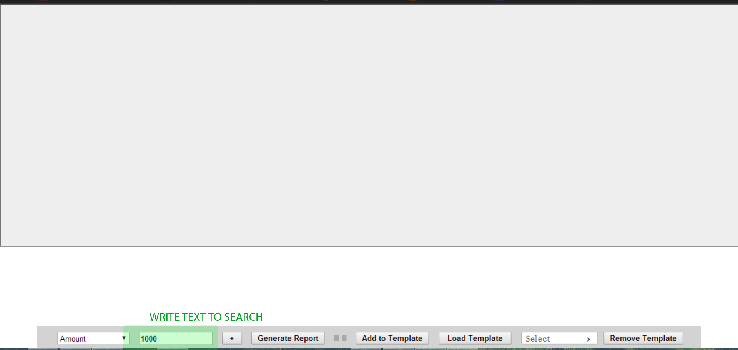
Note that the notation for the type amount is a number, with the decimals marked by the character “.”, and dates follow the format dd/mm/yyyy.

3.Press the “+” button, which creates the Search Tag and initializes the smart search.

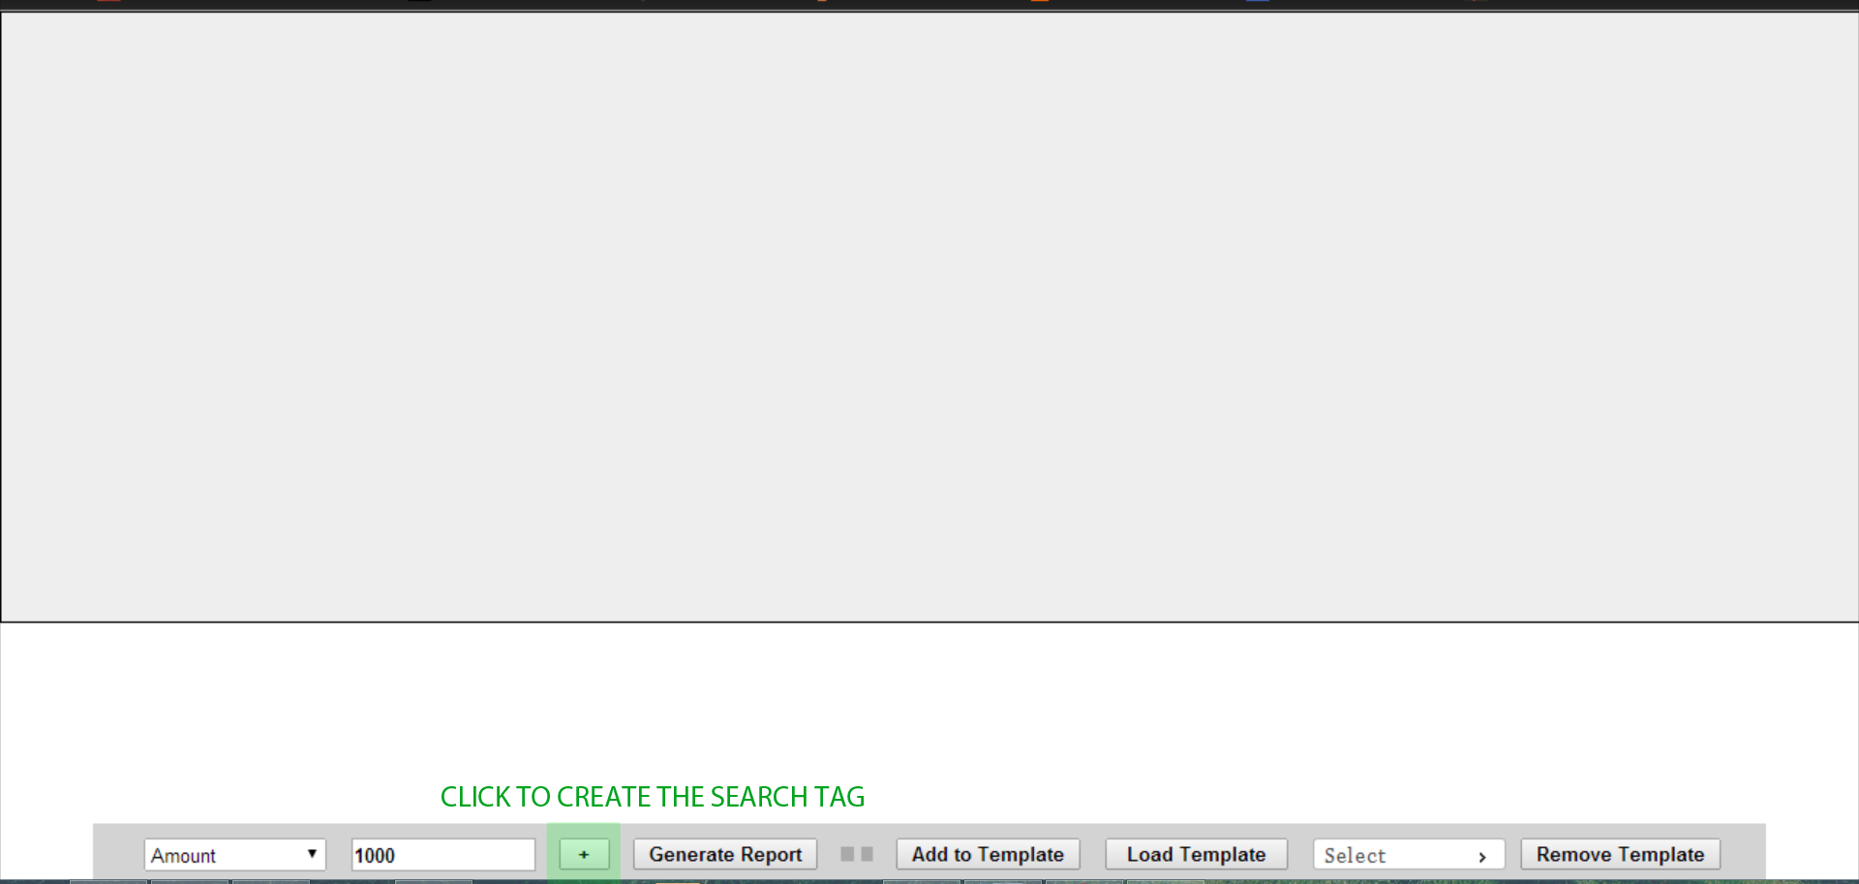

4.The smart search returns the results in the form of candidates (the little ovals), and classifies them by number of coincidences, and shows the newly created tag (Ex: Amount : 1000).

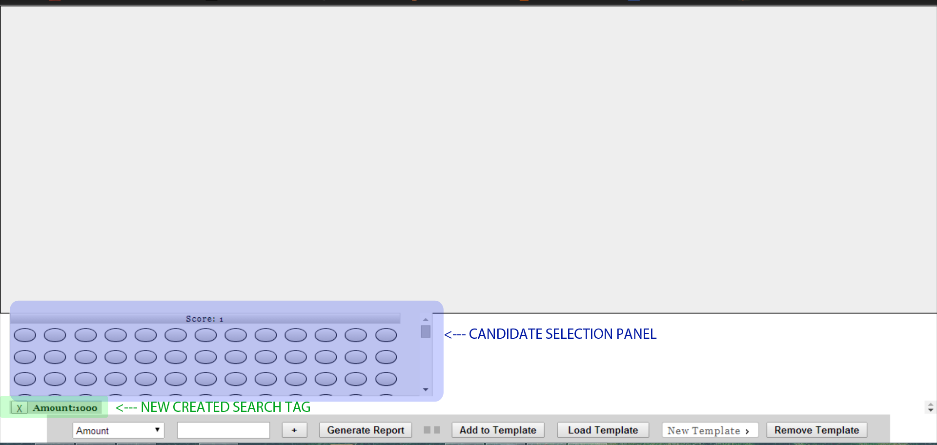

5.Follow the same procedure to keep creating tags, filtering the results further, and obtaining more suitables candidates and better information. At the moment, the maximum number of search tags is 8. You can also erase tags clicking on the “X” on the left of the tag.

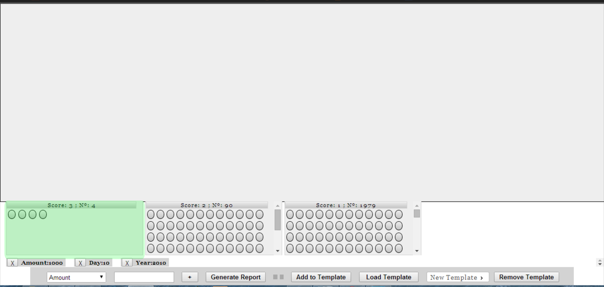
What the different “Score” panels mean, and the distribution of the candidates in them, is the number of transactions that fulfill all the created Search Tags (3 in this case), or only some of them (Ex: Score:2 panel includes the candidates that contain the content introduced in two of the three tags)

It is crucial to note that the Search Tags are inclusive at this moment. This means, that a Tag like “Amount: 1000” will show both Transactions with an Amount of “1000” and Transactions with an Amount of “10000”.

Selecting Candidates:

To select a candidate, click on the corresponding oval. Then, that candidate Transaction will show up in the Exploring Transaction Panel, so you can explore all the related content.
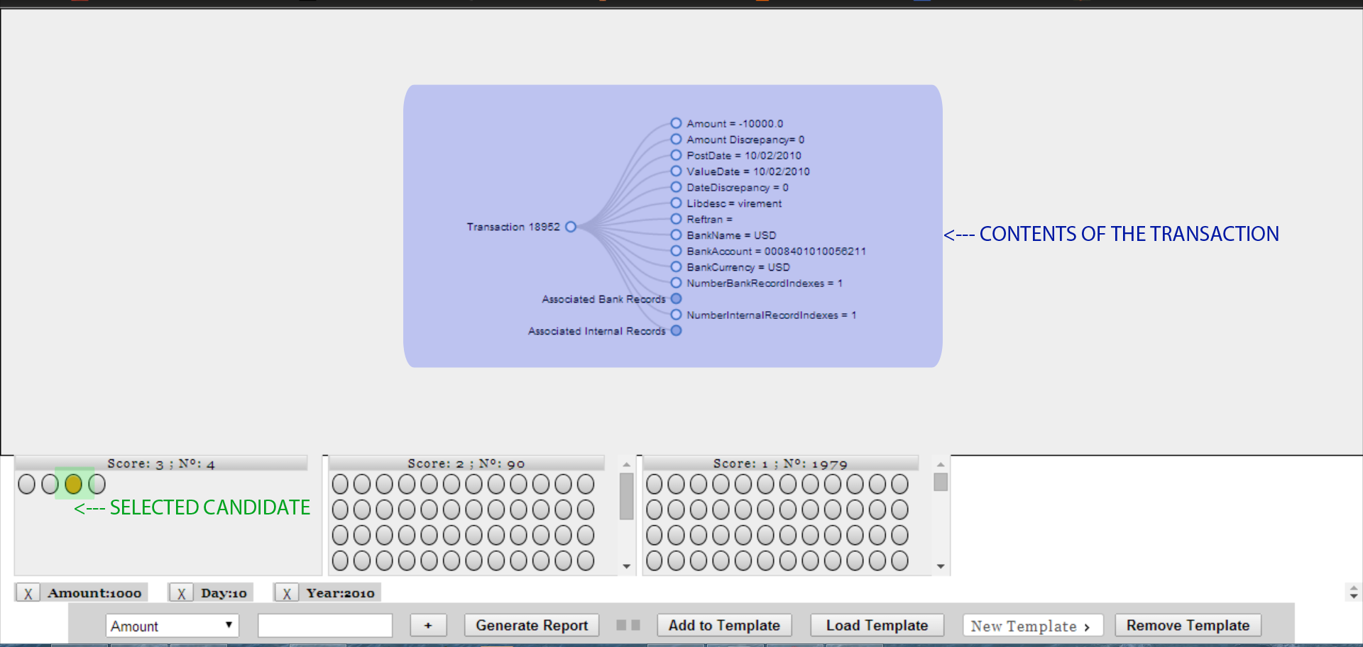

Note: At this moment, the Transaction is not showing the link with any manual entry made from the Ocr corpus of documents, only the Bank Records (Albaraka) and Internal Records (Grande Livre).

Multiple selection of candidates is possible, but only one of them will show up in the Exploring Panel at a time.

To select and deselect, the same controls as in a Windows folder apply.
Control pressed + click selectes/deselects, clicking and dragging the mouse let us select the candidates contained in the drawed square. To select/deselect all members in a single Score Panel, keep Control pressed and click on the Score Panel name.

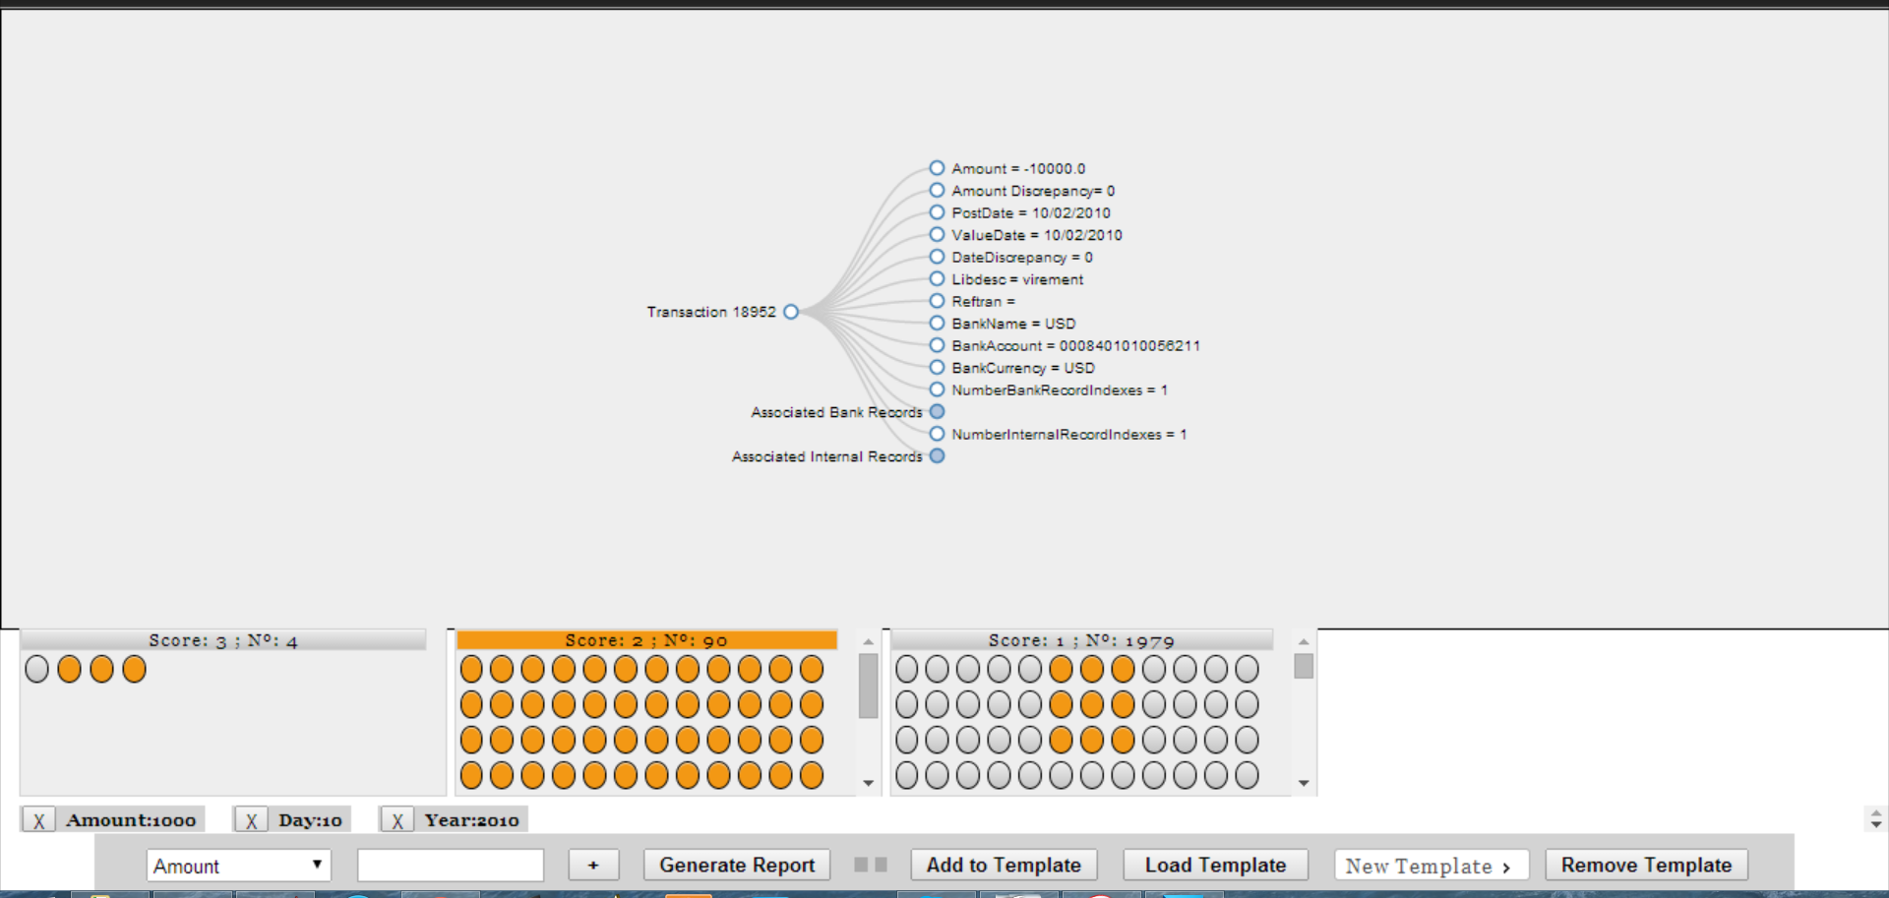

Exploring a Transaction:

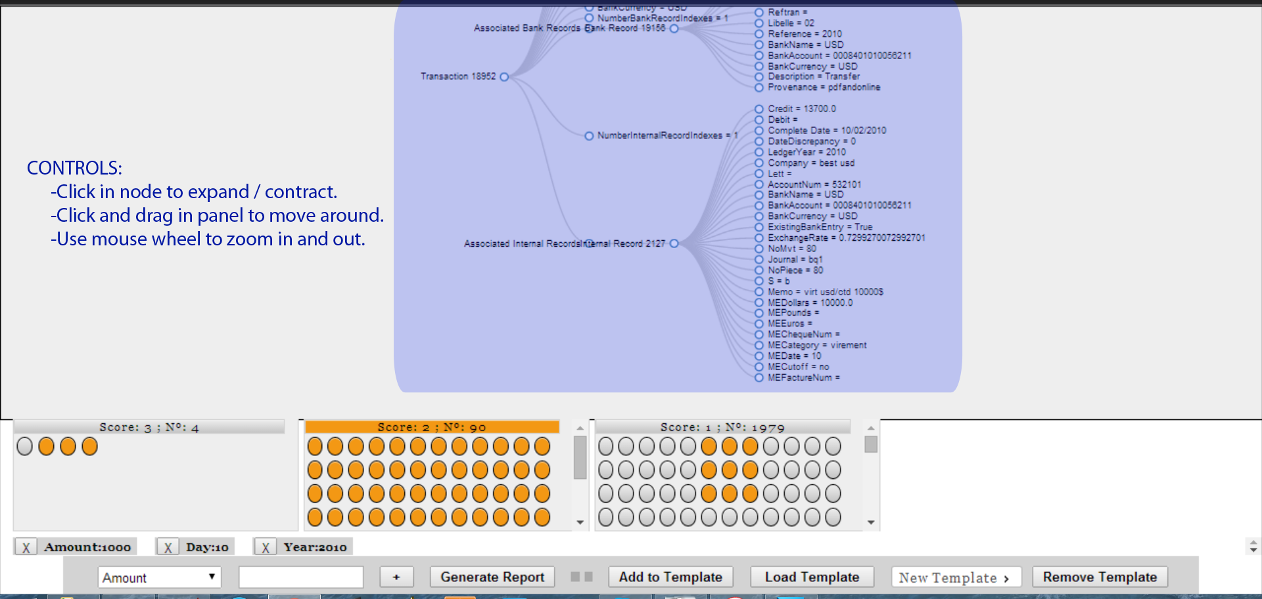

Generating the Report:

Press the button Generate Report to export the selected Transactions (marked in orange color) to a PDF, formatted in a legible structure.

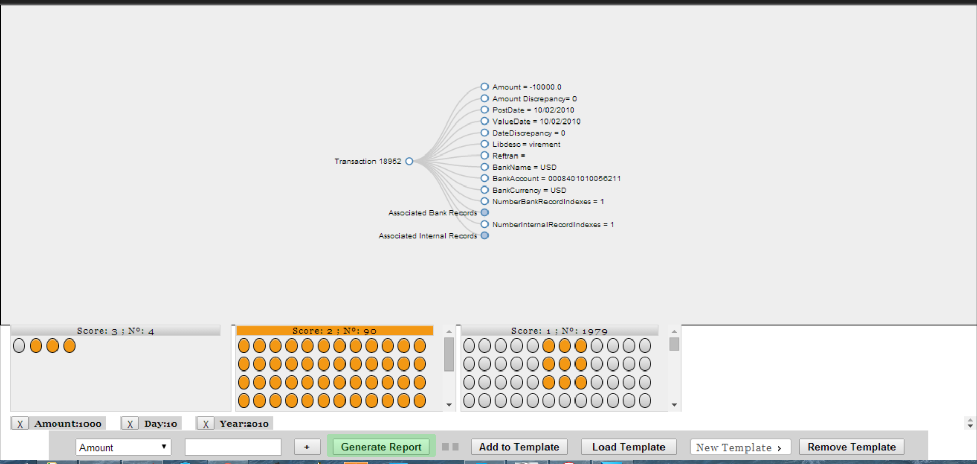
The results are similar to this:

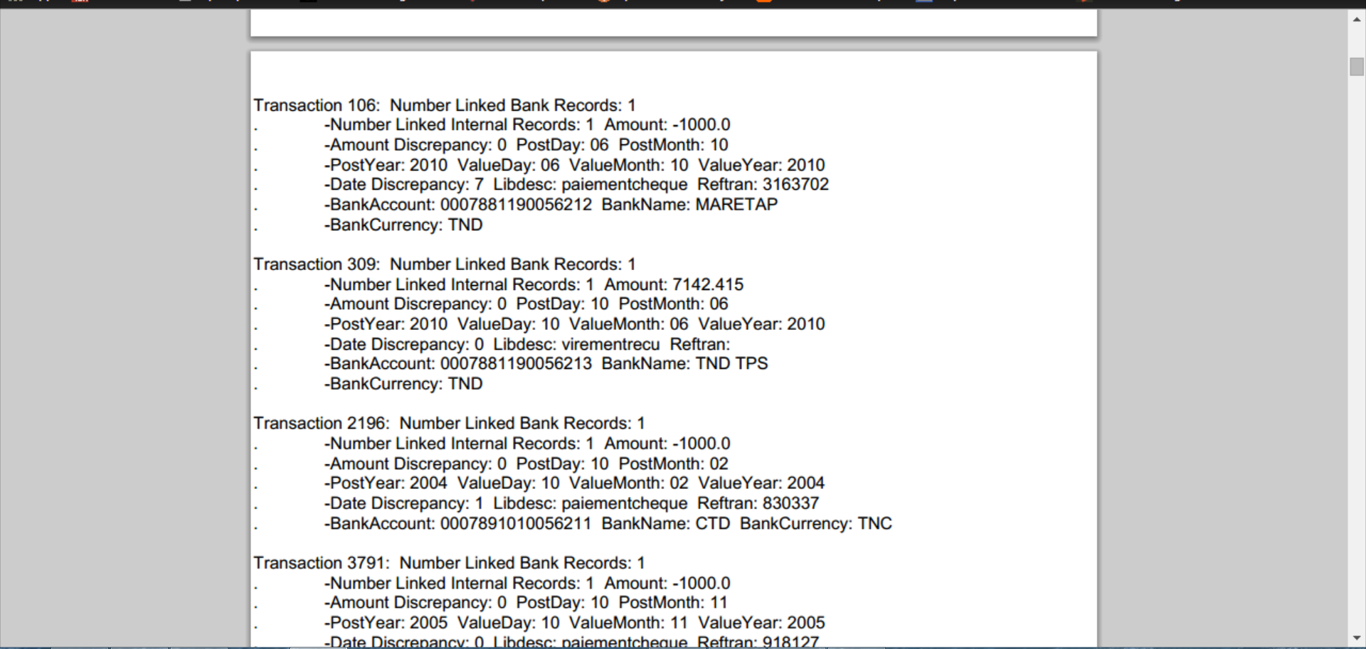
Note that it only Reports the selected candidate transactions, not all of the ones appearing on the Score panels.

TEMPLATES:

Templates are a saved instance of selected candidates, and the search tags that were used to arrive to those candidates. A template can never be modified (saved) to include less search tags or selected candidates that it had in the moment it was saved. However, this changes can be used to generate a Report, or to create a New Template.

Selecting an existing Template, or write a name for a New Template:

Select the Template you want to affect, if there are already existing ones.

You can write a new name for the New Template, or leave it as it is, so a name will be
assigned automatically. (Ex: Unnamed Template 1)

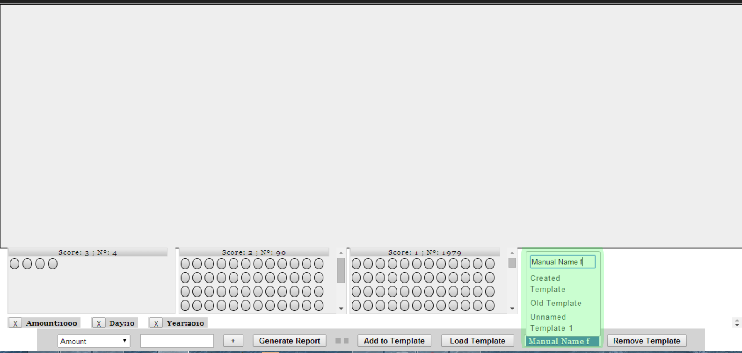
Once the “Add to Template” button is clicked, the Template will be created, and the existing Search Tags (Amount:1000, Day:10, Year:2010) and selected candidates (none in this image) will be added to it.

Adding search tags and selected candidates to a Template:

Create the appropriate Search Tags, select the Transactions you want to keep from the candidates, and select the Template you want to affect when pressing the next button.

Click “Add to Template”, and the existing Search Tags and selected candidates will be added to the previous Search Tags and candidates contained in the Template before.

The important thing to understand is that this is an Addition to the previous content in the Template. You are not overwriting the Template with this action, just adding things to it.

Example:

First search and selection saved in Template “Unnamed Template 2”:

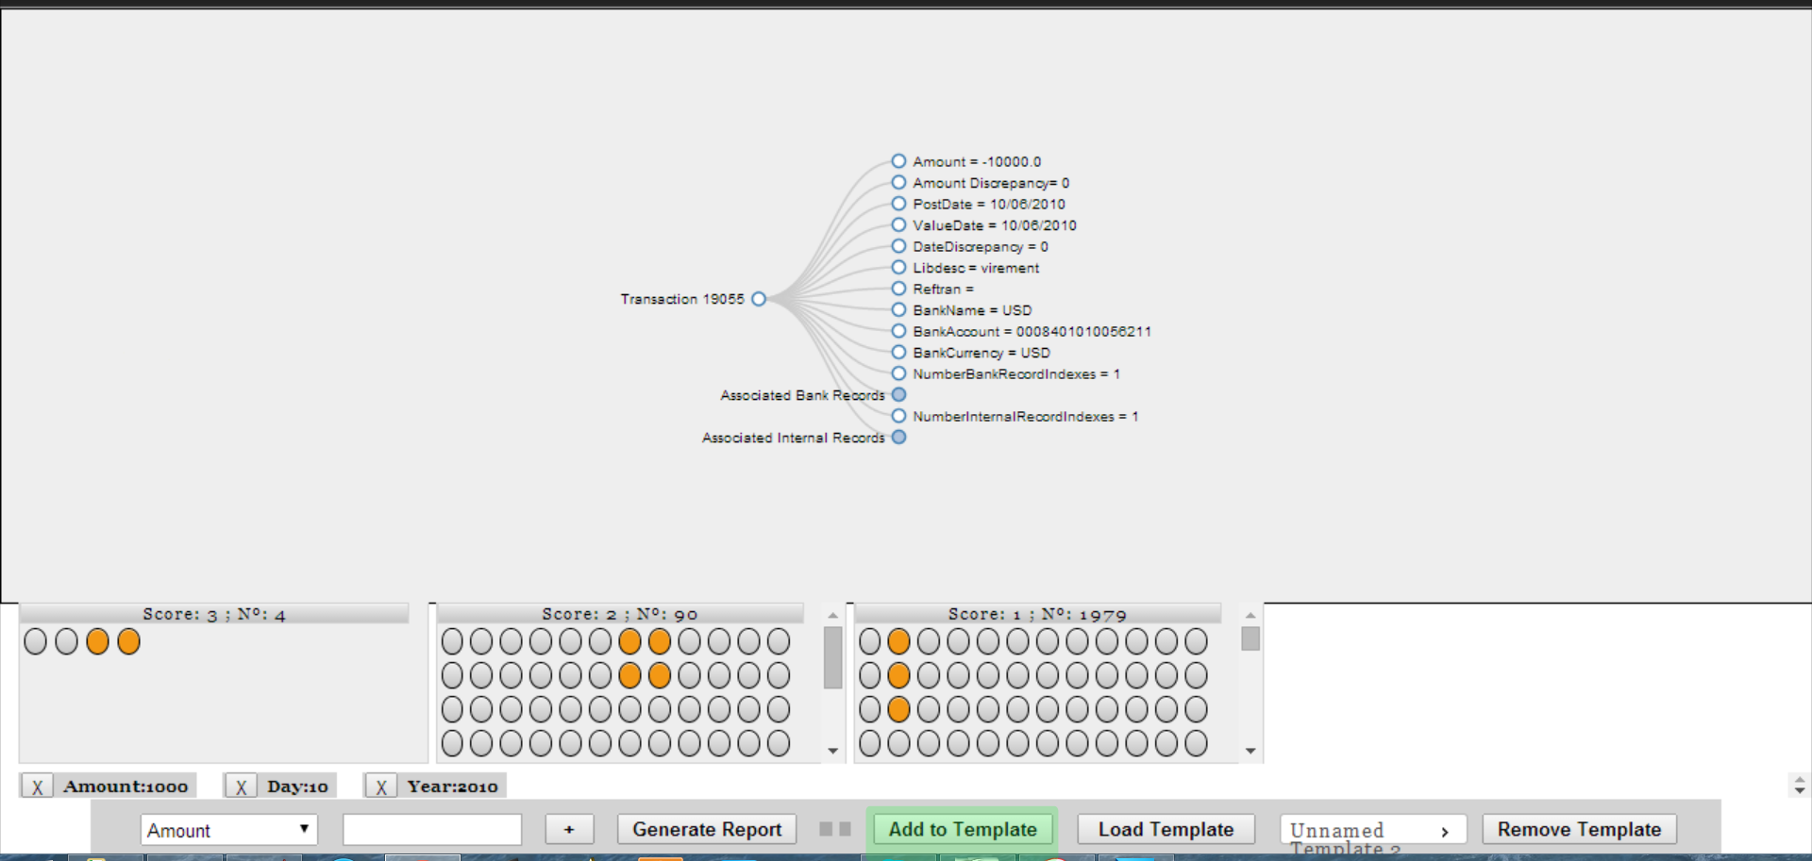

Second search and selection saved in the same Template “Unnamed Template 2”:

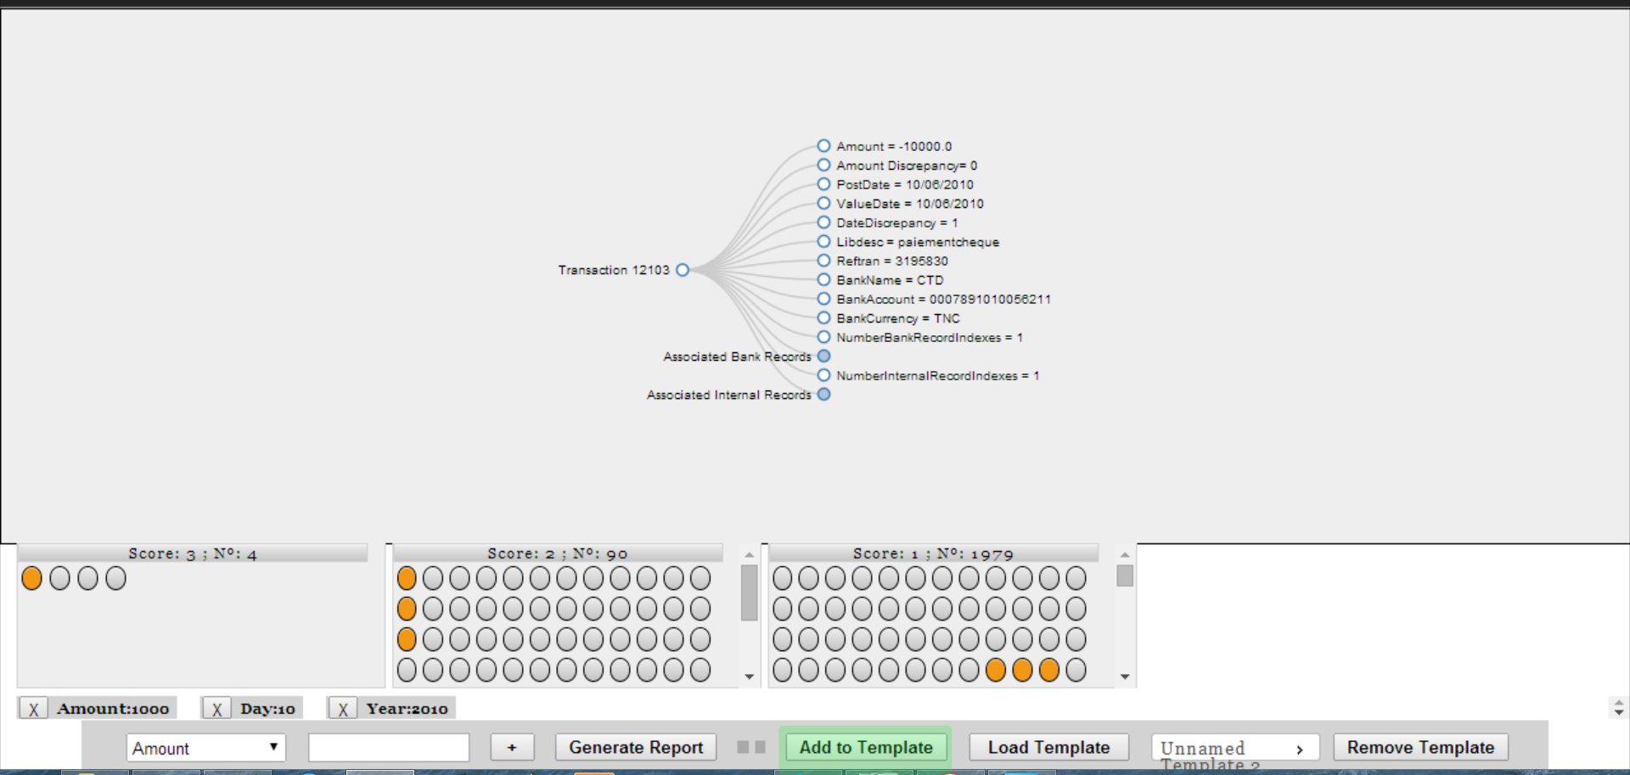

Actual state of Template “Unnamed Template 2” after both additions:

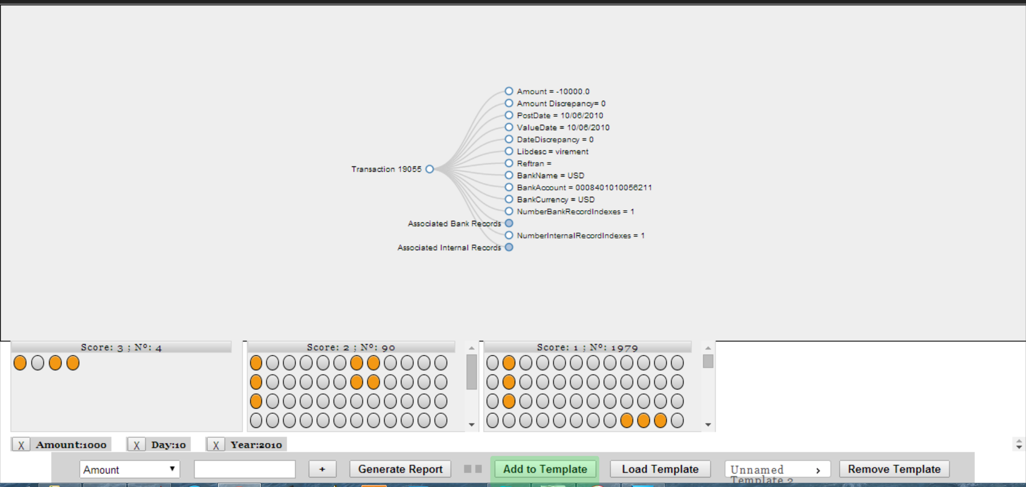

Existing Search Tags would add up in the same way.

Note: At this moment, those actions are not exactly producing this result visually, because the duplicated Search Tags are not being properly merged. But functionally, it does produce this same result.

Loading a Template:

Loading a Template will get back the Search Tags and selections saved in that same Template.

As noted before, duplicated Search Tags are not being merged. As a result, this is the visual representation of the previous “Add to Template” example, when using the “Load Template” button:
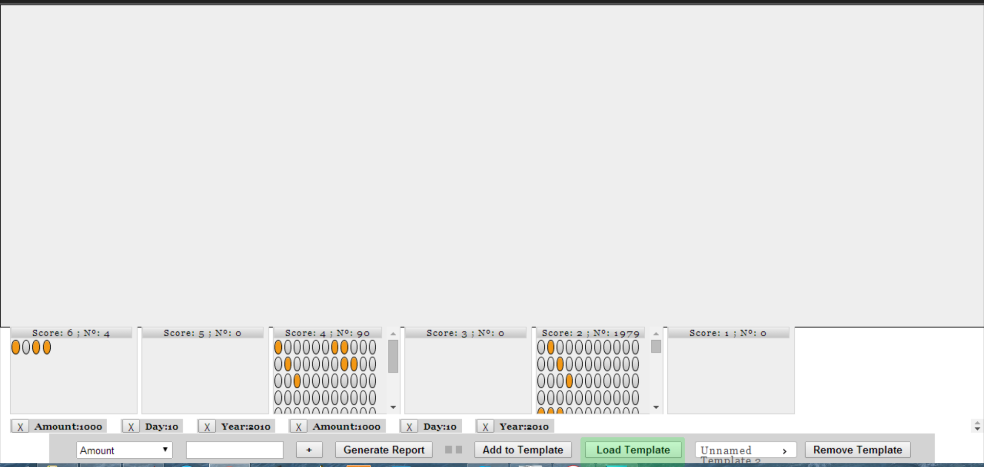

This problem will be solved soon, though the functional implications are minimal.

Remove a Template:

As indicated by the name, this action removes a Template from the database.
This action cannot be undone.

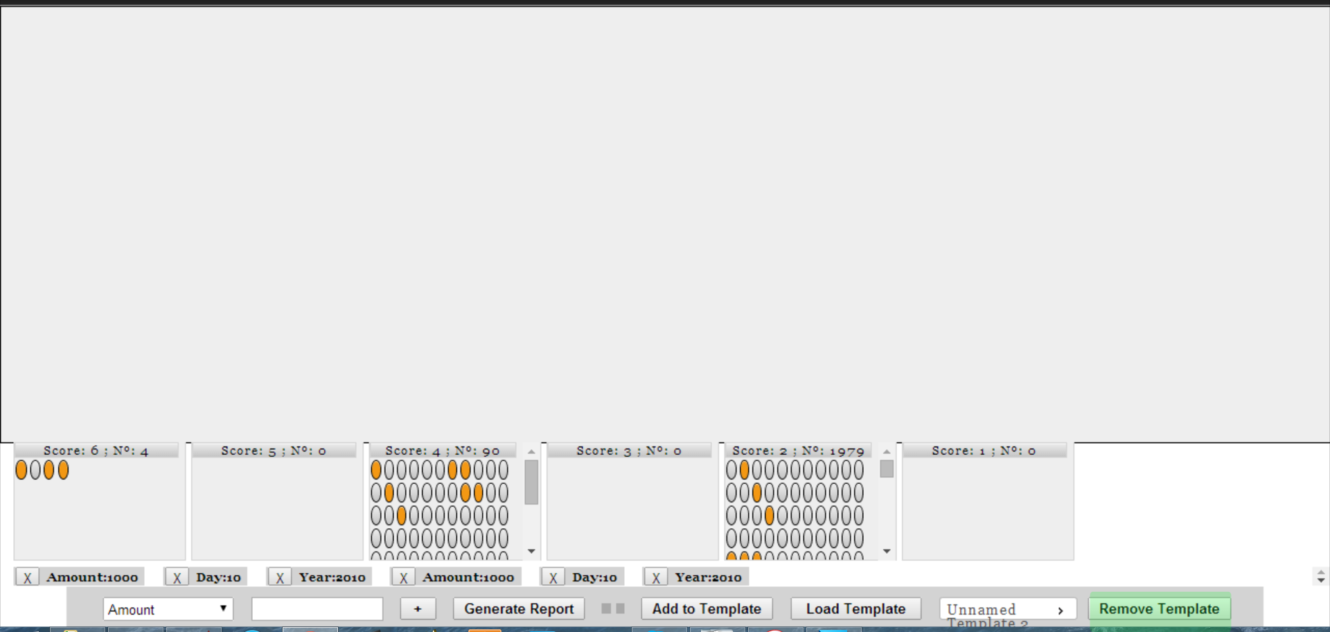
At this moment, Templates are saved in a user-per-user basis, and not for a group/company. This means, only the user can access the Templates saved previously by him.

Extra Interface Knowledge:

Heatmap:

A utility to help you remember which candidates you have clicked before and which not (since the last Search Tag addition/deletion).

Each time you click on a candidate, it's color changes to a darker shade of red.
